36.5: The angle to the first minimum is = arcsin 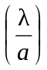 = arcsin 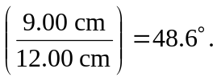
So the distance from the central maximum to the first minimum is just 